**INTERNET OF THINGS ASSIGNMENT RECORD**

**Subject code : BTCS-AMDS-009T**

|  |  |
| --- | --- |
| Name: | Subham Pratik Das |
| Registration Number: | FET-BAML-2022-2026-013 |
| Course: | B.Tech CSE-AIML |
| Semester: | 5th |
| Faculty: | Mr. Biswajeeban Mishra &  Mr. Pritam Nand |

|  |  |
| --- | --- |
| Remarks |  |
| Signature |  |



SRI SRI UNIVERSITY

Bidyadharpur, Cuttack, Odisha.

Index

|  |  |  |  |  |
| --- | --- | --- | --- | --- |
| **Sl. No.** | **Date** | **Experiment/Case Study** | **Page No.** | **Remark** |
| **1** | 9-8-2024 | Prototyping and Arduino UNO R3. |  |  |
| **2** | 9-8-2024 | Encoding formats. |  |  |
| **3** | 9-8-2024 | Basic Structure of an Arduino Program. |  |  |
| **4** |  |  |  |  |
| **5** |  |  |  |  |
| **6** |  |  |  |  |
| **7** |  |  |  |  |
| **8** |  |  |  |  |
| **9** |  |  |  |  |
| **10** |  |  |  |  |
| **11** |  |  |  |  |
| **12** |  |  |  |  |
| **13** |  |  |  |  |
| **14** |  |  |  |  |
| **15** |  |  |  |  |
| **16** |  |  |  |  |

***Assignment No.:1 Date: 9-8-2024***

**Q1. *What is a Prototype?***

***What are Open source and closed source prototype platforms?***

**A:**

* **Prototype**

A prototype is a preliminary model, sample, or version of a product or system used to test a concept or process. It's a tangible representation of an idea, allowing for evaluation, feedback, and refinement before full-scale development. Prototypes can be physical, digital, or a combination of both.

* **Open Source and Closed Source Prototype Platforms**
* Open Source Prototype Platforms: These platforms provide the underlying code and design freely accessible to the public. Users can modify, distribute, and build upon the platform. Examples include Arduino, Raspberry Pi, and open source CAD software like FreeCAD.
* Closed Source Prototype Platforms: These platforms keep the source code proprietary, restricting access and modification. Users typically pay for licenses to use the platform. Examples include many commercial 3D printing software, electronic design automation (EDA) tools, and rapid prototyping machines.

**Q2. *What is Arduino?***

**A: Arduino** is an open-source electronics platform based on easy-to-use hardware and software. It's designed for artists, designers, hobbyists, and anyone interested in creating interactive objects or environments. Arduino boards are microcontroller-based, meaning they have a small computer on board that can be programmed to control various electronic components.

**Q3. *Write down the Arduino Uno R3 Key Specifications.***

**A3.**

* **Main Processor :**

ATmega328P

* **Memory :**

SRAM: 2 KB

FLASH MEMORY: 32 KB (0.5 KB used by bootloader)

EEPROM: 1 KB

* **I/O Pins :**

Digital I/O pins: 14 (of which 6 can be used as PWM outputs)

Analog input pins: 6

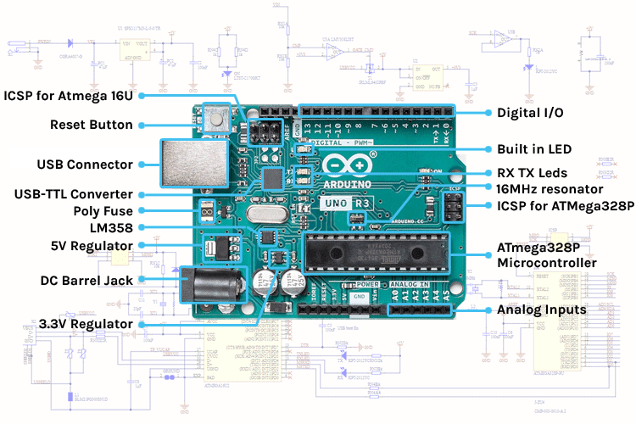

***Assignment No.:2 Date: 9-8-2024***

**Q1. *What is an Encoding format? List down encoding formats for various types of data  ( Text, Number, Photo, Audio, Video).***

**A:** An encoding format is a standardized method for converting data into a specific digital format for efficient storage and transmission. It translates information from human-readable form into a format that computers can interpret. Here’s how encoding formats are used in different contexts.

**Text:**

* [**ASCII (American Standard Code for Information Interchange)**](https://en.wikipedia.org/wiki/ASCII)
* [**UTF-8 (Unicode Transformation Format - 8-bit)**](https://en.wikipedia.org/wiki/UTF-8)
* [**UTF-16 (Unicode Transformation Format - 16-bit)**](https://en.wikipedia.org/wiki/UTF-16)
* [**UTF-32 (Unicode Transformation Format - 32-bit)**](https://en.wikipedia.org/wiki/UTF-32)
* [**ISO 8859-1 (Latin-1)**](https://en.wikipedia.org/wiki/ISO/IEC_8859-1)

**Numbers:**

* [**Binary (Base-2)**](https://en.wikipedia.org/wiki/Binary_number)
* [**Decimal (Base-10)**](https://en.wikipedia.org/wiki/Decimal)
* [**Hexadecimal (Base-16)**](https://en.wikipedia.org/wiki/Hexadecimal)
* [**IEEE 754**](https://en.wikipedia.org/wiki/IEEE_754)
* [**BCD (Binary-Coded Decimal)**](https://en.wikipedia.org/wiki/Binary-coded_decimal)

**Photos or Images:**

* [**JPEG (Joint Photographic Experts Group)**](https://en.wikipedia.org/wiki/JPEG)
* [**PNG (Portable Network Graphics)**](https://en.wikipedia.org/wiki/Portable_Network_Graphics)
* [**GIF (Graphics Interchange Format)**](https://en.wikipedia.org/wiki/GIF)
* [**BMP (Bitmap)**](https://en.wikipedia.org/wiki/BMP_file_format)
* [**TIFF (Tagged Image File Format)**](https://en.wikipedia.org/wiki/TIFF)

**Audio:**

* [**MP3 (MPEG-1 Audio Layer III)**](https://en.wikipedia.org/wiki/MP3)
* [**WAV (Waveform Audio File Format)**](https://en.wikipedia.org/wiki/WAV)
* [**AAC (Advanced Audio Coding)**](https://en.wikipedia.org/wiki/Advanced_Audio_Coding)
* [**FLAC (Free Lossless Audio Codec)**](https://en.wikipedia.org/wiki/FLAC)
* [**OGG (Ogg Vorbis)**](https://en.wikipedia.org/wiki/Vorbis)

**Video:**

* [**MP4 (MPEG-4 Part 14)**](https://en.wikipedia.org/wiki/MPEG-4_Part_14)
* [**AVI (Audio Video Interleave)**](https://en.wikipedia.org/wiki/Audio_Video_Interleave)
* [**MKV (Matroska Video)**](https://en.wikipedia.org/wiki/Matroska)
* [**MOV (QuickTime Movie)**](https://en.wikipedia.org/wiki/QuickTime_File_Format)
* [**WMV (Windows Media Video)**](https://en.wikipedia.org/wiki/Windows_Media_Video)

***Assignment No.:3 Date: 9-8-2024***

***Q1. Explain Basic Structure of an Arduino Program.***

***A1.*** An Arduino program is also called a sketch.

**Basic Structure:**

void setup()

{

statements;

}

void loop()

{

statements;

}

It consists of two main functions:

*1) setup() function*

* Runs only once when the Arduino board starts or resets.
* Used to initialize hardware components, set pin modes (input or output), and define initial values.

*2) loop() function*

* Runs repeatedly after the setup() function completes.
* Contains the core logic of the program.
* This is where the Arduino performs actions and interacts with the environment.

Both functions are enclosed in curly braces {}

Every statement inside these functions is ended with a semicolon ‘ ; ’

**Basic Sketch:**

This simple sketch blinks an LED connected to pin 13.

void setup() {

pinMode(13, OUTPUT); // Set pin 13 as an output

}

void loop() {

digitalWrite(13, HIGH); // Turn LED on

delay(1000); // Wait for 1 second

digitalWrite(13, LOW); // Turn LED off

delay(1000); // Wait for 1 second

}